Event Details
Event Name | 15th Physiotherapy Summit – Physiofest 2025 – An International Conference
Association or collaboration agencies | SSIP, IIIC, CFE, Rajkot Physiotherapy Association
Event Date | 4th & 5th April, 2025
Event Place | School of Physiotherapy, RK University, Rajkot
Number of Participants | 450
The Objective of the Event | Pioneering Physiotherapy: Innovating Practice, Elevating Standards

Focus areas | Description
Description cum Executive Summary with pictures of an Event  +  Event Highlights: | - The event emphasized translational innovations in physiotherapy, encouraging participants to integrate clinical insight with forward-looking techniques and standards. The aim was to elevate the benchmarks of physiotherapy care globally through academic exchange and applied innovations.  - Physiofest 2025, the 15th edition of RK University’s flagship Annual Physiotherapy Summit, successfully brought together leading physiotherapists, clinicians, researchers, and students from across the country. This year's central theme, "Pioneering Physiotherapy: Innovating Practice, Elevating Standards," laid the foundation for a robust exchange of knowledge, clinical acumen, and academic excellence.  - Shri Shamjibhai Harjibhai Talaviya Charitable (SHTC) Trust-managed School of Physiotherapy, RK University continues its legacy since 2009 of organizing Physiofest to empower students and professionals with quality inputs in the field of physiotherapy.  - The summit was inaugurated through a video message by Chief Guest Dr. Ygna Shukla, inspiring all delegates with her forward-looking message on physiotherapy’s evolving role in healthcare systems.  - Guests of Honour gracing the summit included:  - Dr. Christopher Pedra, Head, Department of Sports Medicine, H.N. Reliance Hospital, Dr. Alap Shah, Founder & Director, Mission Health, Dr. Ali Irani, HoD, Physiotherapy & Sports Medicine, Nanavati Super Speciality Hospital, Mumbai, Dr. Smita KC, Lecturer, KUSMS & Consultant Physiotherapist, Dhulikhel Hospital, Nepal, Dr. Vaishali Sreejith, Senate Member, RGUHS  - The conference hosted 25 expert speakers who delivered cutting-edge talks and shared clinical advancements across various specializations in physiotherapy. The two panel discussions enriched the summit by creating multidisciplinary dialogues on the future of physiotherapy and integrating digital health tools into clinical practice.  - The conference hosted 25 expert speakers who delivered cutting-edge talks and shared clinical advancements across various specialisations in physiotherapy. The two panel discussions enriched the summit by creating multidisciplinary dialogues on the future of physiotherapy and integrating digital health tools into clinical practice.
Participant List | - Total Attendees: 450
Winner / Ranker List | - A total of 40 Winners were awarded in various categories of events.
Feedback and Surveys: | • Participant Feedback:  Feedback collected post-event revealed high satisfaction among delegates regarding the quality of sessions, expert speaker engagements, and the logistical execution of the event.  • Sponsor Feedback:  All sponsors expressed their appreciation for the professionally managed event and reported meaningful engagement with attendees.
Media and Coverage: | - A dedicated website and digital registration portal were developed for Physiofest 2025.  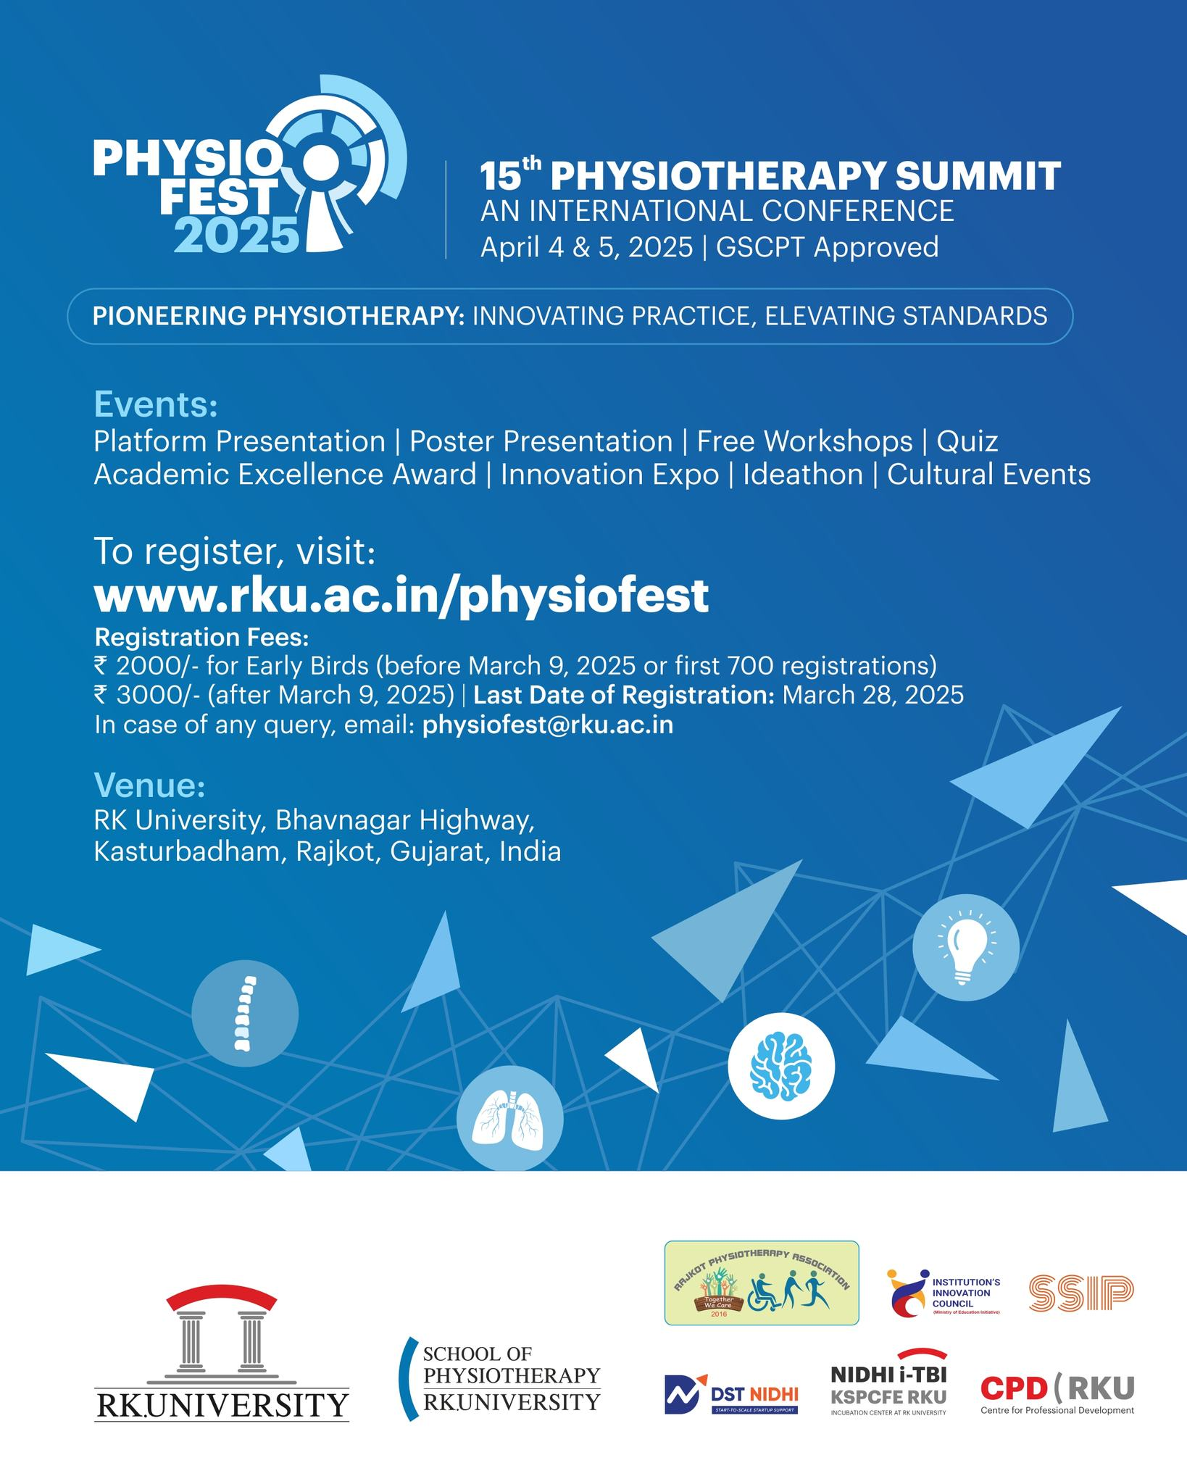  - Social Media Promotion was extensively carried out via Instagram, Facebook, LinkedIn, and Twitter.  - Photos and session highlights were shared in real-time.  - Media coverage included event glimpses by local press and allied health platforms.  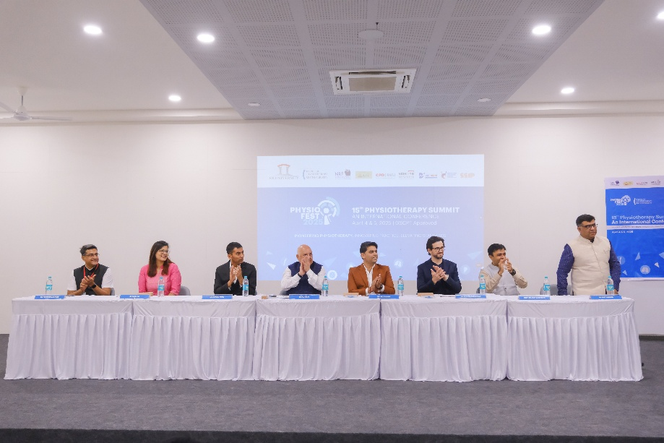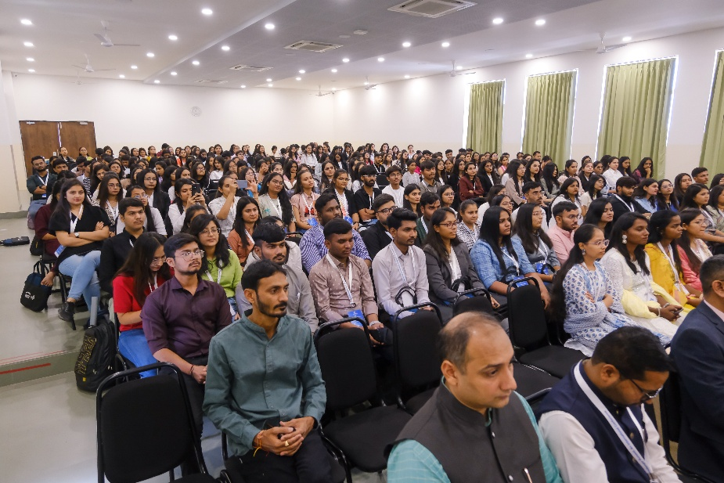  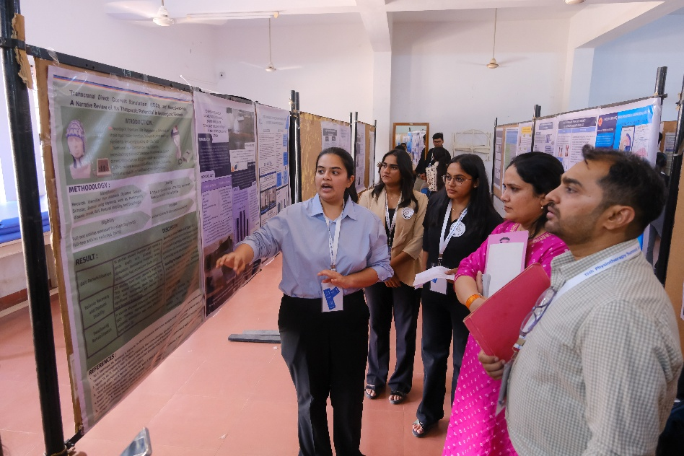  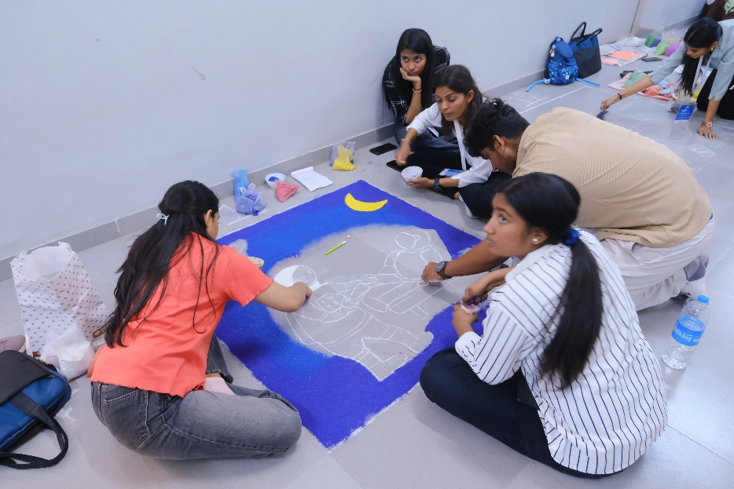  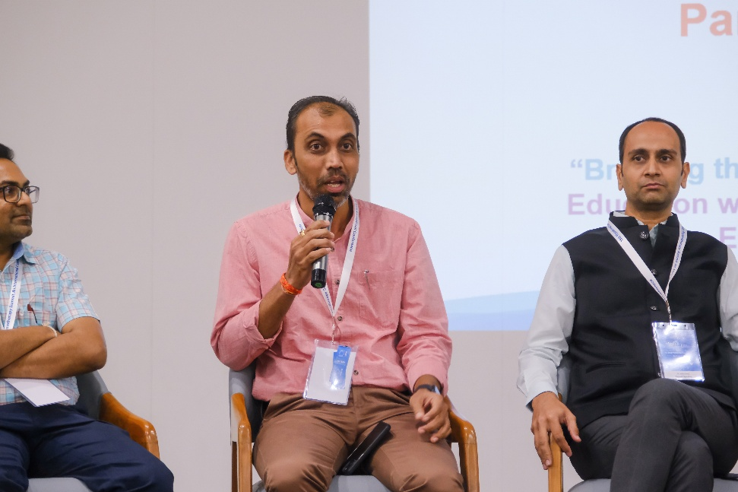  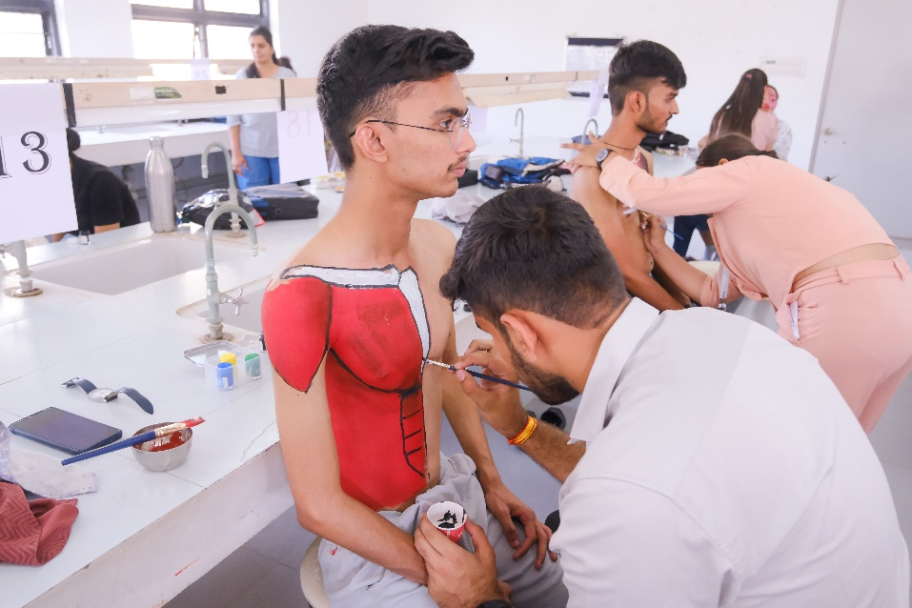
Acknowledgements: | - RK University extends heartfelt gratitude to all dignitaries, keynote speakers, panellists, session moderators, and academic coordinators for their invaluable contribution to making Physiofest 2025 a grand success.  - Special thanks to:  - Dr. Ygna Shukla for her virtual inauguration and motivating words.  - Dr. Amit Lathigara (Vice Chancellor) and Mr. Mohit Patel (Executive VP) for institutional leadership.  - Dr. Priyanshu Rathod Sir for guiding the evolution and academic stature of Physiofest.  - Director, Dr. Amit Sharma Sir for his unwavering support and visionary planning.  - All event coordinators, faculty, student volunteers, and delegates whose dedication and enthusiasm drove the success of this landmark summit.

